**Project Report:** Fake News Detection Using Natural Language Processing (NLP)

**Executive sumary:**

In an era characterized by the rapid dissemination of information through digital channels, the proliferation of fake news poses a significant threat to society. The rise of social media and online news platforms has made it easier for misinformation to spread, potentially causing harm to individuals, communities, and even democracies. This report explores the role of Natural Language Processing (NLP) in the detection of fake news, providing an overview of the challenges, methodologies, and future prospects in this critical field.

Introduction

**Background**

Fake news, often defined as deliberately fabricated or misleading information presented as factual news, has gained prominence in recent years. Its impact on public opinion and decision-making processes underscores the need for robust methods to detect and combat this phenomenon.

**Objectives**

This report aims to

* Discuss the challenges of fake news detection.
* Explore the role of Natural Language Processing (NLP) in addressing these challenges.
* Present methodologies and techniques employed in fake news detection using NL
* Highlight real-world applications and case studies.
* Offer insights into the future of NLP-based fake news detection.

**Challenges** **in** **Fake** **News** **Detection**

* Information Overload

The sheer volume of online content makes it challenging to identify and verify the accuracy of every piece of information.

* Evolving Tactics

Those spreading fake news continually adapt their tactics, making it difficult to rely solely on predefined rules.

* Contextual Ambiguity

Fake news often relies on the manipulation of context and interpretation, making it hard to distinguish from genuine news.

**Role of NLP in Fake News Detection**

* Text Analysis

NLP techniques, such as sentiment analysis and topic modeling, can be used to analyze the content of news articles and social media posts for anomalies.

* Source Credibility Analysis

NLP can help assess the credibility of sources by analyzing historical data, writing style, and past accuracy.

* Contextual Understanding

Advanced NLP models, like transformers, enable a deeper understanding of context, improving the identification of fake news.

**Methodologies and Techniques**

* Supervised Learning

Machine learning algorithms are trained on labeled datasets to classify news articles as fake or genuine.

* Unsupervised Learning

Clustering and anomaly detection techniques are employed to identify suspicious patterns in data.

* Hybrid Approaches

Combining supervised and unsupervised methods can improve accuracy and adaptability.

**Real-World Applications**

* Social Media Monitoring

NLP-based tools are deployed on platforms like Twitter and Facebook to flag potentially fake news posts.

* Newsroom Assistance

News organizations use NLP to fact-check and verify information before publication.

* Government Initiatives

Governments employ NLP for early detection of misinformation campaigns and foreign interference.

**Future Prospects**

* Deep Learning Advancements

Continued advancements in deep learning models will enhance NLP’s ability to detect subtle nuances in fake news.

* Multimodal Analysis

Integrating text analysis with image and video analysis will be essential in addressing the evolving nature of fake news.

* Ethical Considerations

The responsible use of NLP in fake news detection must address privacy concerns and potential biases.

**Innovation to solve the problem:Fake News Detection Using Natural Language Processing (NLP)**

**Detecting fake news using Natural Language Processing (NLP) is a critical challenge. Here's an innovative approach to tackle this problem:**

* *Deep Learning Models:*

develop advanced deep learning models, such as Transformers (like GPT-4), specifically fine-tuned for fake news detection. These models can understand context, semantics, and nuances in text, making them more effective at spotting misleading information.

* *Multimodal Analysis:*

Incorporate image and video analysis alongside text analysis. Fake news often includes manipulated images and videos. Combining NLP with computer vision can enhance accuracy in identifying misleading content.

* *Source Verification:*

Create a database of reputable news sources and use this as a reference to verify the credibility of a given news article. If the source is not in the database or has a questionable history, it raises suspicion.

* *Real-Time Fact-Checking:*

Implement a real-time fact-checking system that can cross-reference claims made in news articles with verified data from trusted sources. This can be done using automated fact-checking algorithms.

* *User Behavior Analysis:*

Analyze user behavior on social media platforms and news websites. Look for patterns of sharing and engagement with fake news stories. Machine learning algorithms can flag suspicious user activity.

* *Semantic Analysis:*

Go beyond keyword matching and employ semantic analysis to understand the meaning and context of sentences. Fake news often relies on subtle language manipulation, which can be detected through semantic analysis.

* *Linguistic Style Analysis:*

Develop models that analyze the writing style of authors. Fake news authors may have distinct patterns in their writing style, which can be used for identification.

* *Collaborative Filtering:*

Utilize collaborative filtering techniques to identify fake news based on what similar users have flagged as suspicious. This can help in collective efforts to detect misinformation.

* *Blockchain for Verification:*

Explore blockchain technology to create a decentralized system for news verification. Each article could be timestamped and linked to its source, ensuring transparency and tamper-proof records.

* *Education and Awareness:*

Invest in public education campaigns to raise awareness about fake news and critical thinking skills. Educated users are less likely to fall victim to misinformation.

* *Partnerships with Social Media:*

Collaborate with social media platforms to integrate fake news detection tools directly into their systems. This can help in flagging or removing misleading content quickly.

* *Continuous Learning:*

Ensure that the NLP model is continually updated and fine-tuned to adapt to evolving techniques used by purveyors of fake news.

**Combining these approaches and leveraging the power of NLP and AI can significantly improve the accuracy and effectiveness of fake news detection, helping to combat the spread of misinformation**

Problem Statement:

Begin building the fake news detection model by loading and preprocessing the dataset. Load the fake news dataset and

preprocess the textual data.

Data Cleaning:



Data cleaning is a process of removing inconsistencies in the dataset and incorrect values .It also in involves handling missing values

either by removing them or assigning them average values. It helps to improve the efficiency of the model.

In the first step, we will only remove the unnecessary data points from the dataset which does not helps in improving the model

performance.

Initially we import the necessary packages for our data cleaning process and also in the future purposes,

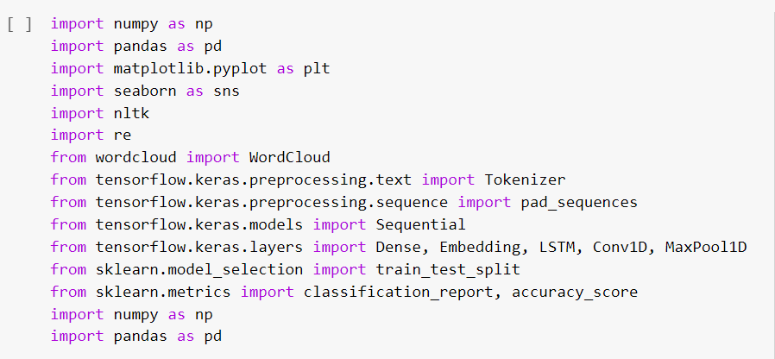

we use these packages in various stages of our cleaning process and also in the future in which we need to build models.

Here, we read the .csv files of true and fake news and then explore the count values of their subjects

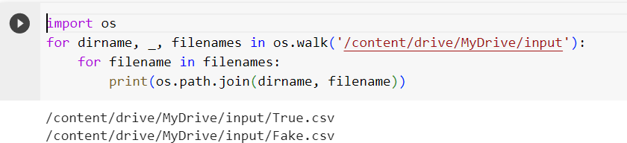

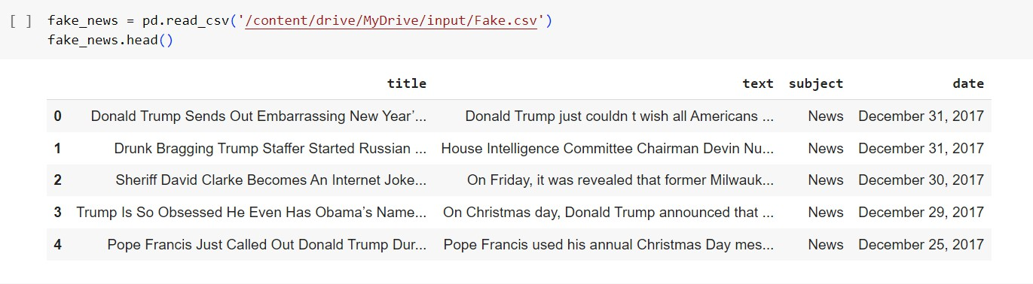

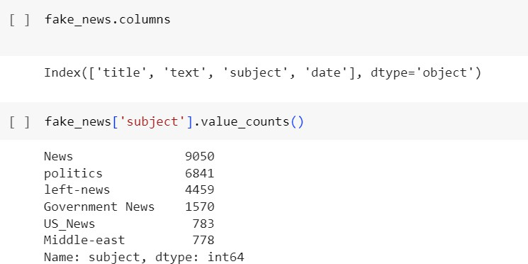

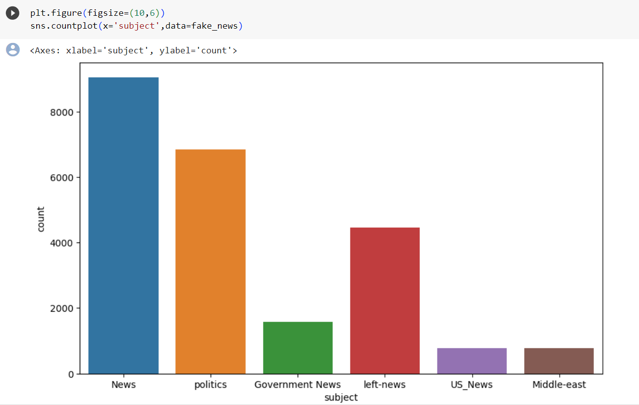

Here , we have used wordcloud to see that which word has mostly used for the fake news. By seeing that we can make a conclusion

that which topic(about a person, event or anything) is mostly contains fake news).We also do the same for true news.

Word Cloud for Fake News:

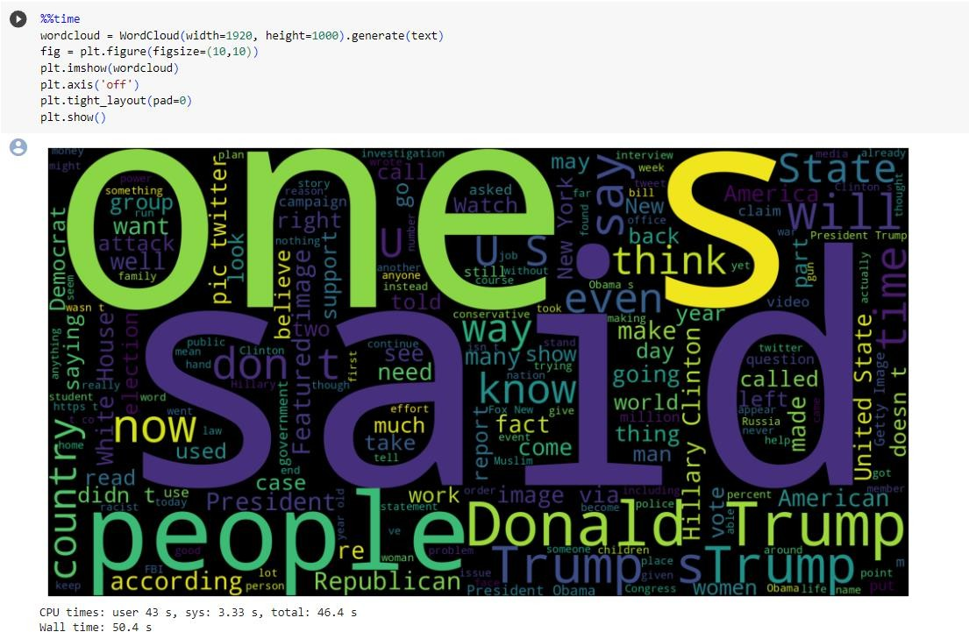

Word cloud for True News:

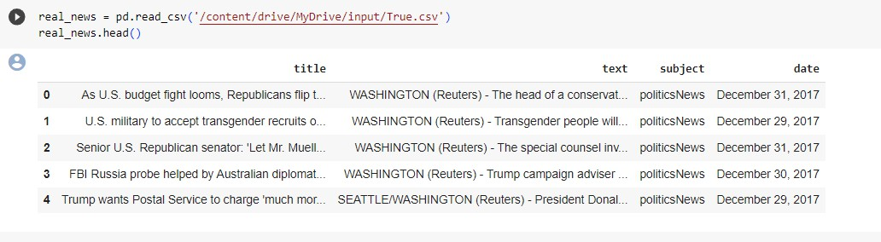

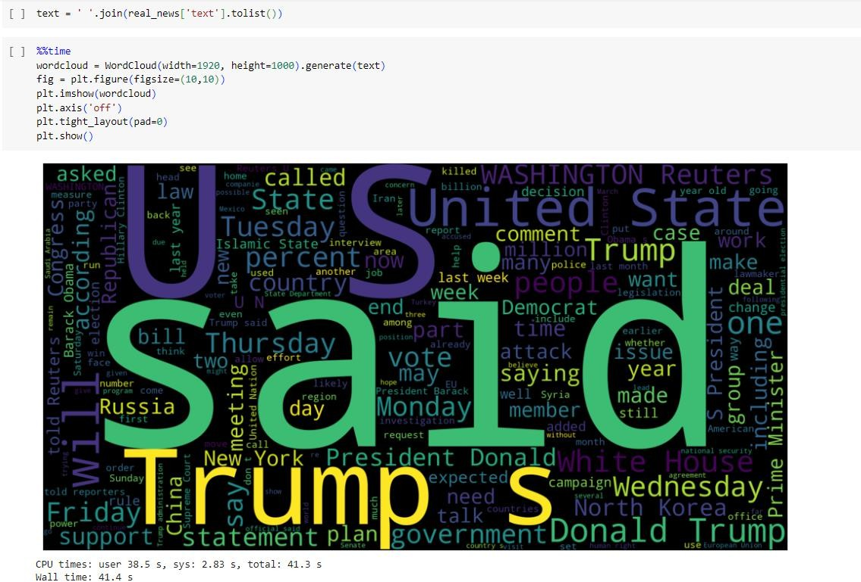

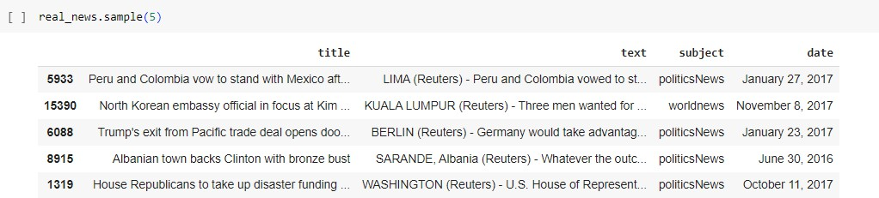

Let’s create a list of news lists in real_news.csv with unknown publishers by using the following code snippets

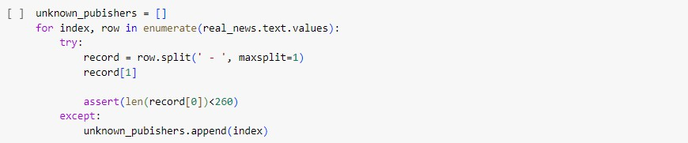

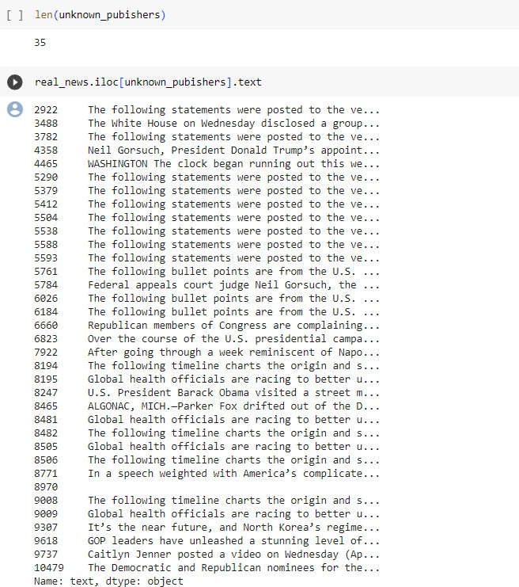

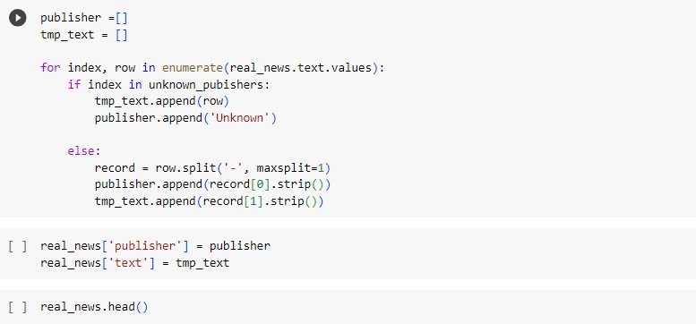

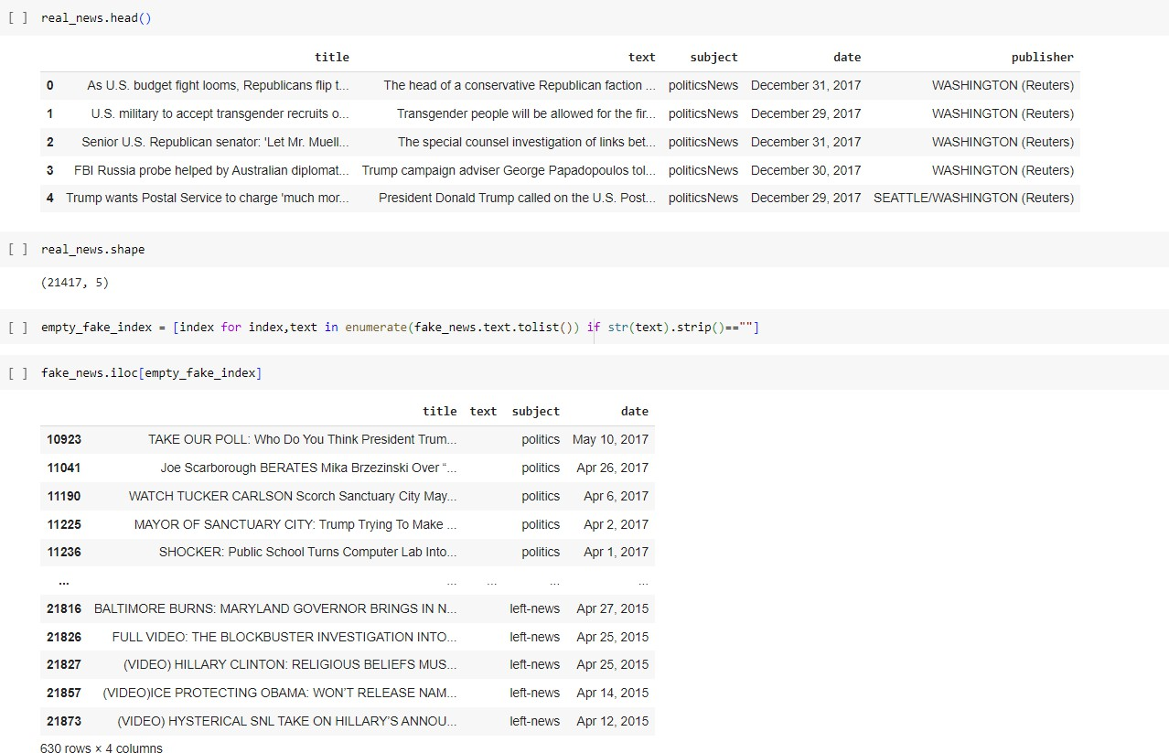

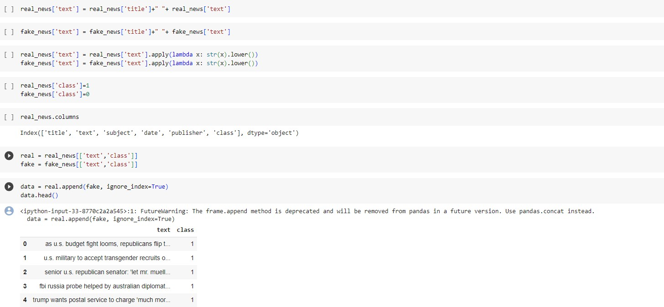

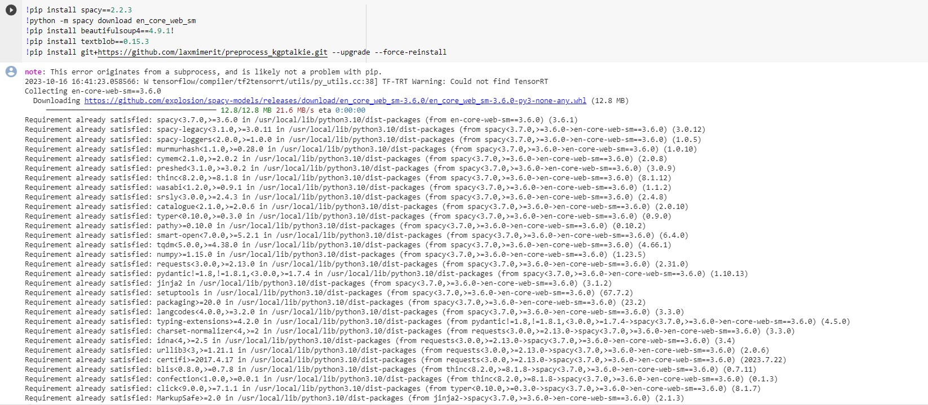

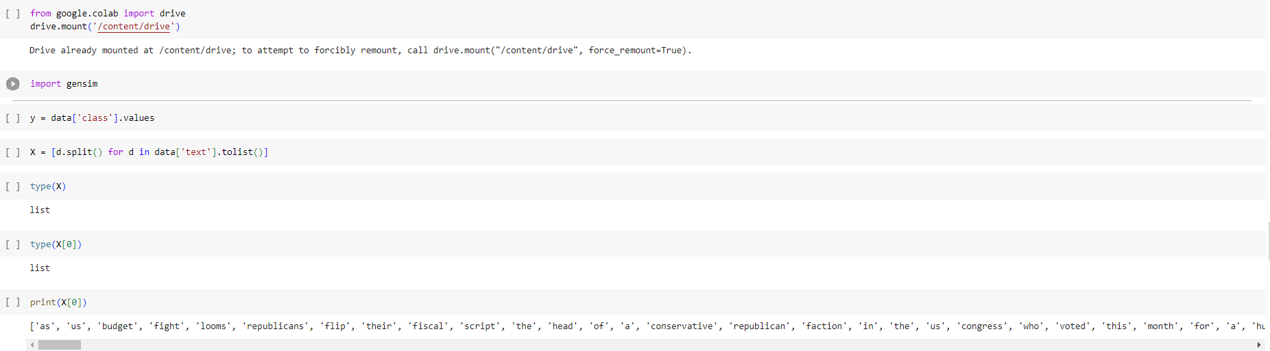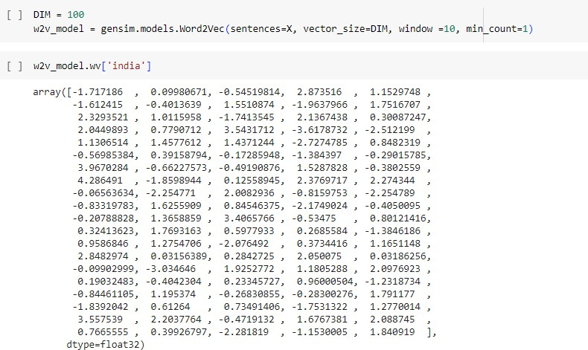

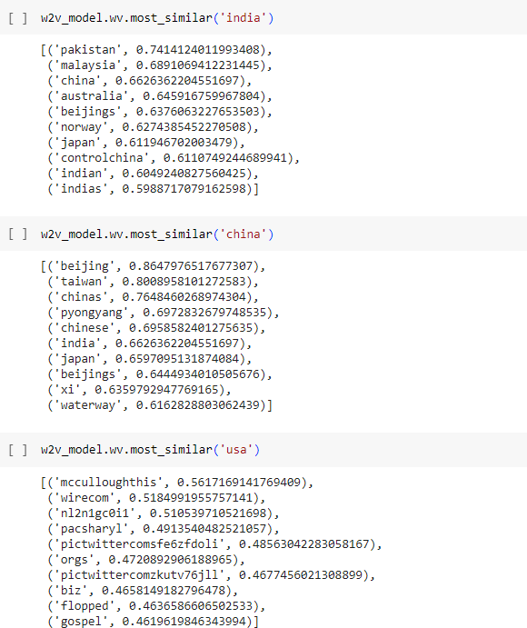

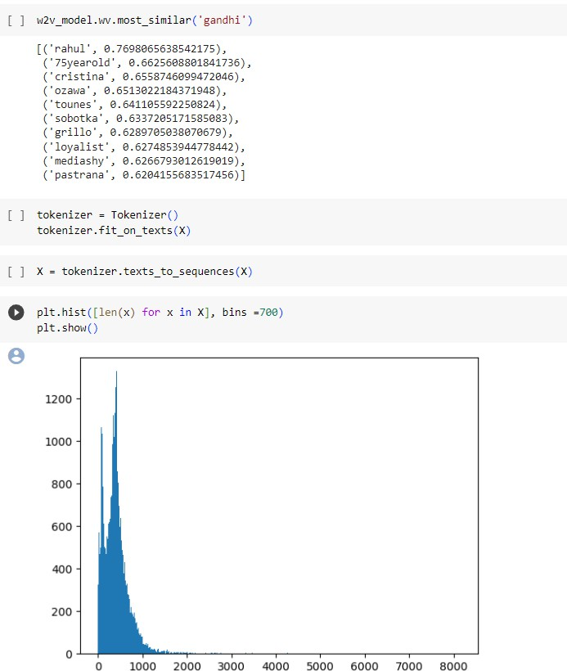

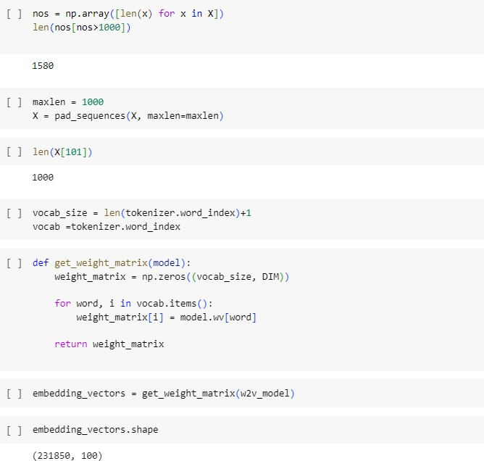

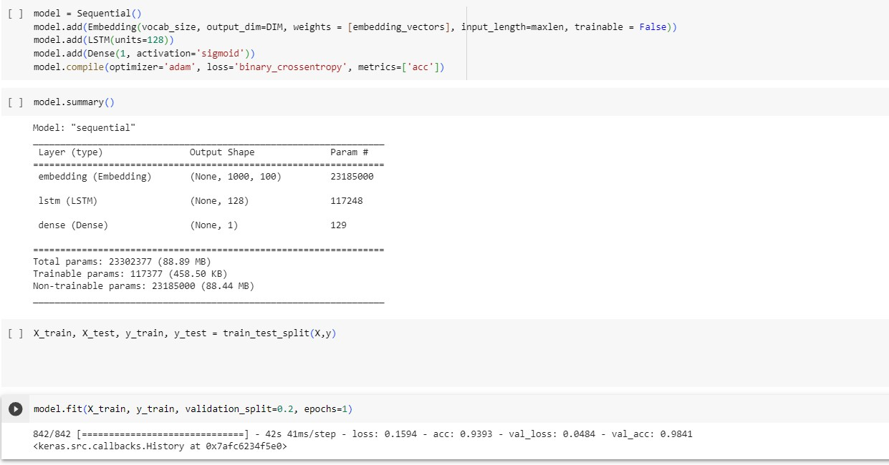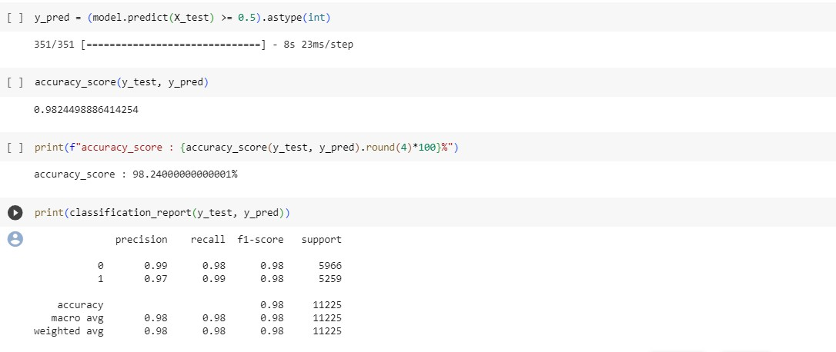

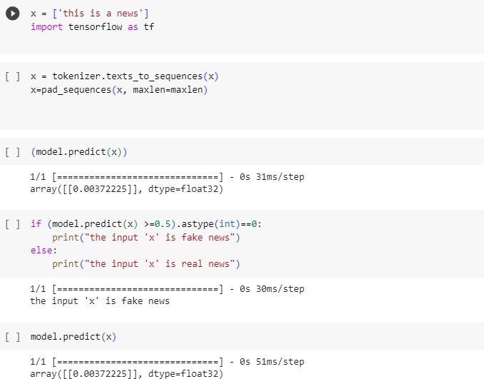

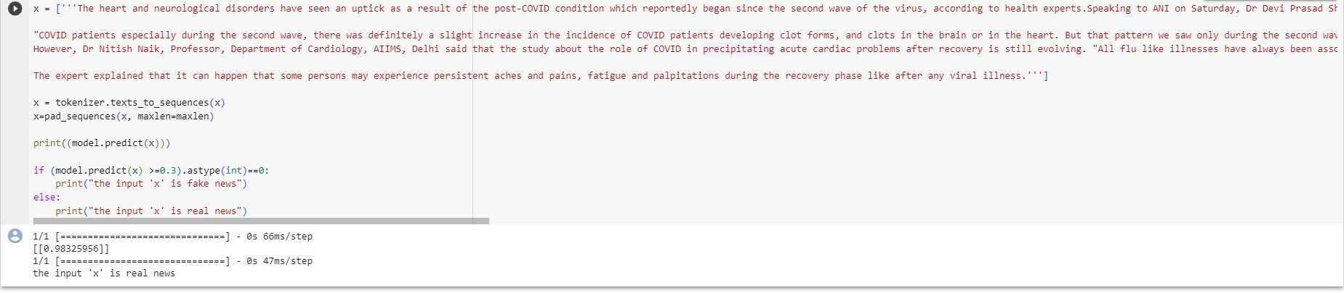

**Fake News Detection using NLP and Machine Learning in Python**

Step by Step guide for fake news detection using machine learning, natural language processing in python

In this post, we will be discussing fake news detection using machine learning and will start to understand what is fake news, and what is the source of its generation?

**What is Fake news?**

Fake news is a form of news that consists of falsified information or hoaxes to deceive users for clickbait. Clickbait is the technique for grabbing the attention of users with flashy headlines which makes them click the link with the purpose of generating revenue by showing different advertisements. Today, with the increasing usage of social media, spreading fake news over the internet, increases manifold and the major source of spreading fake news is online news portals which makes it really difficult to distinguish between real and fake news. In this case study, we will discuss how we can detect fake news from news headlines using natural language processing (NLP) and machine learning-based techniques. The full code used in this post is available in my Github repo.

**About Data**

The dataset used in this case study is the ISOT Fake News Dataset. The dataset contains two types of articles fake and real news. This dataset was collected from real-world sources; the truthful articles were obtained by crawling articles from Reuters.com (News website). As for the fake news articles, they were collected from different sources. The fake news articles were collected from unreliable websites that were flagged by Politifact (a fact-checking organization in the USA) and Wikipedia. The dataset contains different types of articles on different topics, however, the majority of articles focus on political and world news topics.

The dataset consists of two CSV files. The first file named contains more than 12,600 articles from reuter.com. The second file named contains more than 12,600 articles from different fake news outlet resources. Each article contains the following information:

Article title (News Headline),

Text,

Label (REAL or FAKE)

Exploratory data analysis

In this case study, we have extracted interesting patterns from the news headline text using NLP and perform exploratory data analysis to provide useful insights about real and fake news headlines.

**Snapshot of dataset**

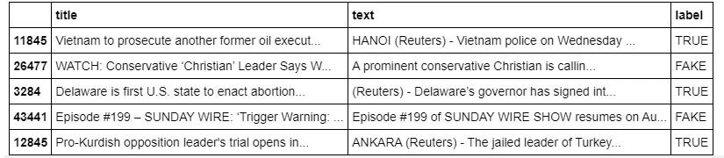Figure 1 shows the top 5 entries of the actual dataset used in the case study.

Figure 1. Snapshot of the actual dataset used in the case study

Distribution of Fake news

Firstly, we check the distribution of fake and true news in the dataset by plotting the bar graph as shown in Figure 2.

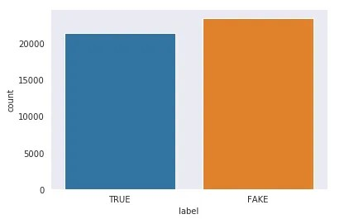

Figure 2. Distribution of Real and Fake news in the dataset

As we have seen from the above figure, the dataset is balanced having 21417 true news and 23481 fake news.

**Distribution of the number of characters**

Next, we have checked the distribution of the number of characters in the fake and true news titles. From the below figure it is evident that the average number of characters is higher in case of fake news in comparison to true news.

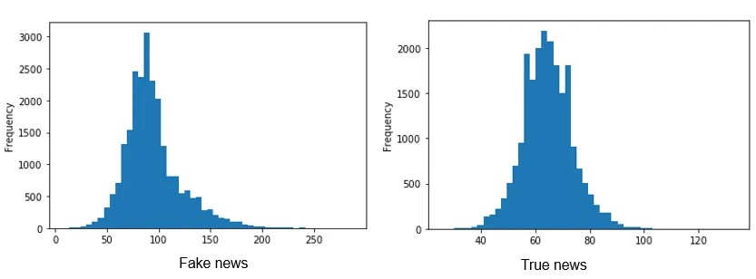

Figure 3. Distribution of the number of characters in fake news (left) and true news (right)

Distribution of unique words

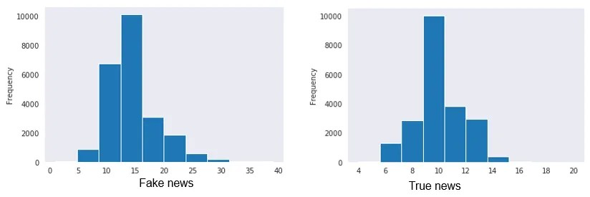Further, we have checked the distribution of unique words used in both fake news and true news titles. As per the figure, it is observed that fake news consists of more unique words in comparison to true news as its main objective is to deceive users with the use of attention-grabbing words in the headlines.

Figure 4. distribution of unique words used in fake news (left) and true news (right)

**Distribution of special characters**

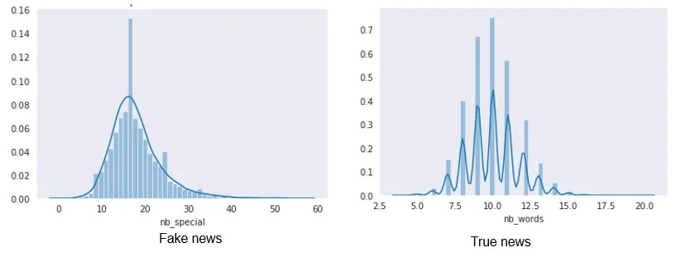In the end, we have checked the distribution of special characters used in both fake and true news and found that more special characters are used in fake news in comparison to true news.

Figure 5. distribution of special characters in fake news (left) and true news (right)

Word Cloud to plot the most frequent words

So, next, we will plot the most frequent words in fake news and real news using the word cloud. Word cloud is a technique for visualizing most frequent words in a text corpus where the size of the words represents their frequency. For plotting word cloud we have used word cloud python library.

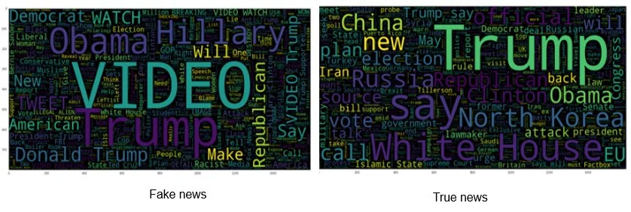

Figure 6. Word cloud representation of fake news and real news

As we can see from the above figure, most frequent words in fake news are Video, Obama, Hillary, Trump and Republican whereas Real news comprises Trump, White House, North Korea, China, etc.

**Text pre-processing**

After analyzing the data, we move towards text pre-processing before building machine learning models. The text pre-processing consists of the following steps:

Step 1: Lower casing

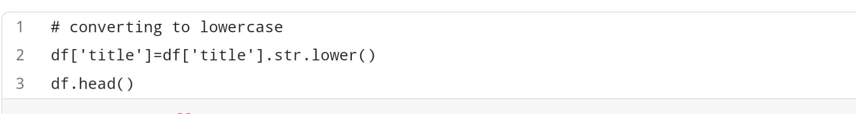In the lower casing, we convert all the words in the text in lower case as words VIDEO and video are the same in contextual meaning but it represents different words in vector space resulting in more dimensions.

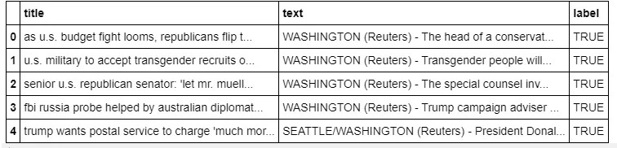

So, as we can see from the above data frame, all the text in the title column is now converted to lower case. Here df is the pandas data frame using which we have loaded the dataset.

Step 2: Stop word removal

Stop words are the most common words used in regular conversation and it does not add significant value in the conversation. The examples of stop words are a, an, the, he, she, it, etc. So In text classification tasks, we use to remove such stop words by importing stop words defined in nltk corpus. The python code for removing stop words are shown below:

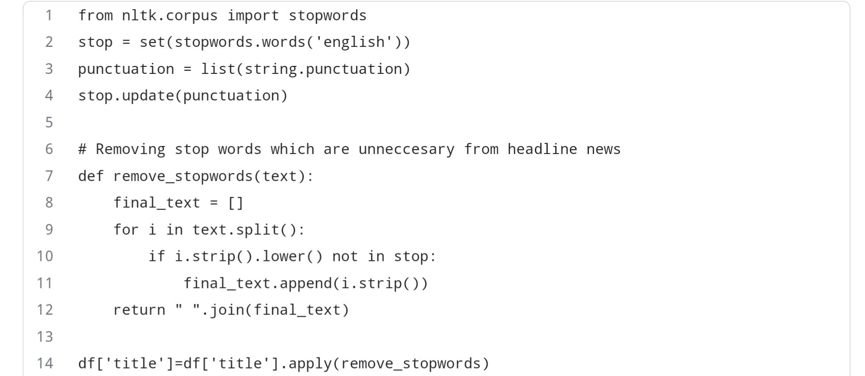

Step 3: Special character removal

In this step, we remove all types of special characters in the news title. The special characters are also not significant for text classification and it only increases the total dimension in vector space, so we filter them out before building the machine learning model. The code for filtering out special characters is shown below.

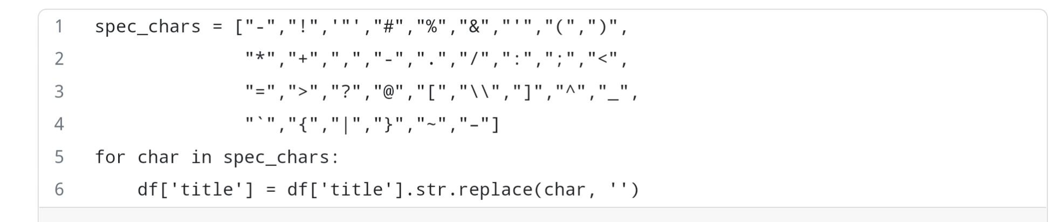

It is important to note that, stemming and lemmatization are considered important steps but for this case study we have not performed any of them either, but you are free to try them and see how the final result changes.

Train Test Split

In this step, we split the data into train and test set in the ratio of 75:25 i.e., 75% of the data used in training the model and rest 25% used for testing the model. The code for splitting data is shown below.

**Model building**

First, we have built our baseline model with a count vectorizer. Count vectorizer converts the text document to a vector of token counts. The actual working of the count vectorizer is shown in the below figure.

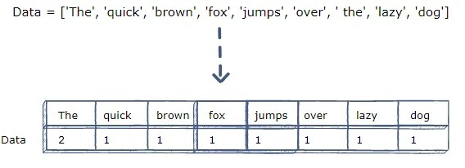

So, as we can see from the below figure, the sentence “The quick brown fox jumps over the lazy dog” is converted into a frequency table in which column represents tokens in the sentence and rows represents the corresponding frequency of those tokens.

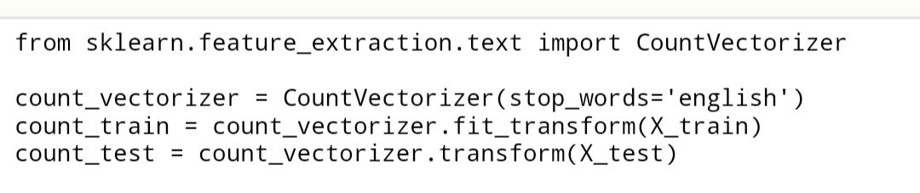

So, the code for applying the count vectorizer to the text document is shown below. Code vectorizer is defined in sklearn python library

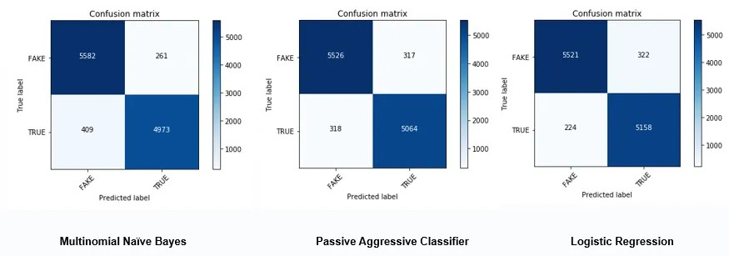Next, with count vectorizer, we have used three machine-learning algorithms Multinomial Naïve Bayes which generally performs better in case of text classification, Passive Aggressive classifier, and Logistic regression algorithms. The results of these algorithms in terms of the confusion matrix are below.

Figure 7. Figure showing the confusion matrix of Multinomial Naïve Bayes (Left), Passive-aggressive classifier (Middle) and Logistic regression (Right) using count vectorizer

As we can see from Figure 7, the highest true positives and true negatives detected by the logistic regression algorithm while the second best is a passive-aggressive classifier.

To improve the performance of our machine learning algorithms we have used the TFIDF vectorizer. TFIDF vectorizer converts the text document into a matrix of TFIDF features. Now lest see what is TFIDF ? and why it performs better than count vectorizer?

Now, let’s break down TFIDF into TF i.e., Term Frequency and IDF i.e., Inverse Document Frequency.

Term Frequency (TF)

Term Frequency represents the number of times a word appears in a document divided by the total number of words in the document. The formulae of Term frequency is mathematically shown as below.

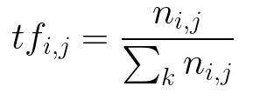

Inverse Document Frequency (IDF)

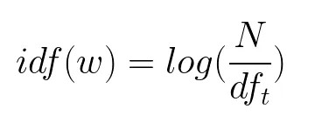It represents the log of the number of documents divided by the number of documents containing the word w. Inverse data frequency used to weight the rare words across all documents in the corpus.

The reason why TFIDF performs better than count vectorizer is that TFIDF gives higher weight to rare words across all the documents whereas count vectorizer gives importance to common words which are of very little importance in text classification.

The code for Implementing TFIDF is defined in the form of a library that is defined under sklearn.

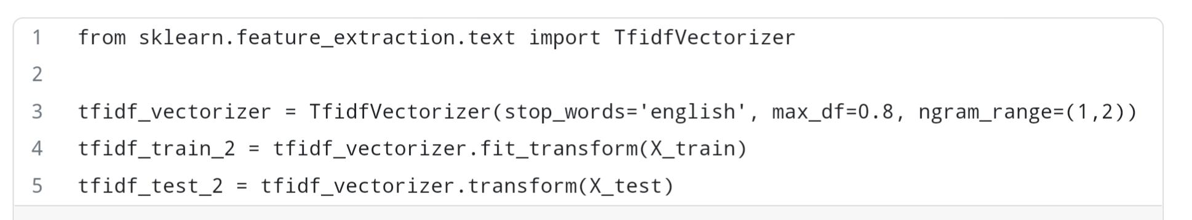

TFIDF Hyperparameters

Now let’s talk about its hyper-parameter first one is stopwords which is defined for making aware that stopwords used in the text are of English language, max_df is used for removing terms that appear too frequently, In our case, we have taken its value as 0.8 which means remove those words which appear in more than 80% of the documents and the last hyper-parameter is ngram_range which is set as (1,2) i.e., it will allow both unigrams and bigrams.

Next, with the TFIDF vectorizer, we have used the same machine-learning algorithms i.e., Multinomial Naïve Bayes, Passive Aggressive classifier, and Logistic regression algorithms. The results of these algorithms in terms of the confusion matrix is shown below.

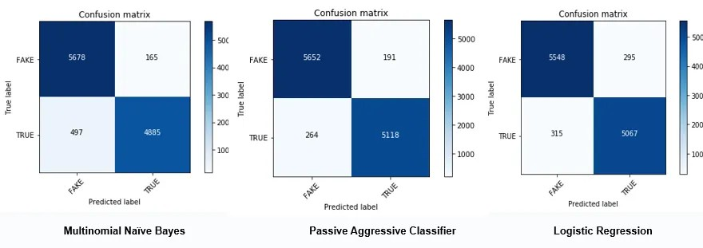

Figure 8. Figure showing the confusion matrix of Multinomial Naïve Bayes (Left), Passive-aggressive classifier (Middle) and Logistic regression (Right) using TFIDF vectorizer

**Result Analysis**

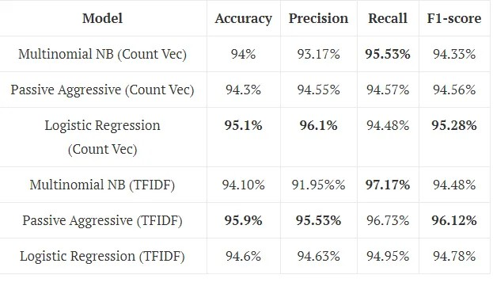Now let’s see detailed results of both count vectorizer and TFIDF vectorizer and compare which one performs better. Now, let’s compare both the techniques and find which one performs better.

**Findings and discussion**

As per the above Table, Passive Aggressive classifier with TFIDF outperforms others in terms of accuracy, precision, and F1-score whereas the highest recall achieved by Multinomial Naïve Bayes which is really surprising. The important thing to notice that after applying TFIDF significant improvement observed in the performance of all three algorithms in comparison to the count vectorizer. In the case of count vectorizer, Logistic Regression outperforms others in all the performance measures except recall.

**Feature Importance**

Now, let’s see what are the most informative features in predicting Fake and True news with the TFIDF vectorizer. The top 10 key features in predicting fake news are shown below.

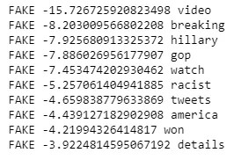The top 10 key features in predicting true news are shown below.

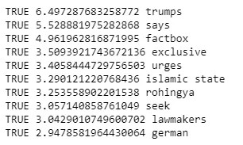

As we can see from the above figures, the first column is the label the second column consists of coefficient and the last one are the top contributing features. From the figure, it is evident that top features in the case of Fake News are the lowest negative value whereas in the case of true news highest positive value.

In most of the top fake and true news, only unigrams are present while in case of true news one bigram feature is also present i.e., Islamic state

**COMBINING :**

In tackling a complex problem, our journey begins with a precise problem statement. Design thinking becomes our compass, guiding us through user-centric innovation—from empathizing with user needs to prototyping solutions. The development phases orchestrate a strategic symphony, harmonizing planning, design, implementation, testing, and maintenance. Anchored in a robust dataset, its origins and nuances shape our analytical landscape. Data preprocessing sweeps away imperfections, ensuring a pristine canvas for our insights. Feature extraction then sculpts meaningful attributes from the data's raw tapestry. The heartbeat of our solution lies in a carefully chosen classification algorithm, a meticulously crafted instrument for the task at hand. Model training, the grand finale, refines our creation, balancing precision and generalization. This orchestrated process encapsulates the art and science of problem-solving, where innovation meets pragmatism on the quest for impactful solutions**.**

**WHY IS FAKE NEWS DETECTION UNSIN (NLP)**

**IMPORTANT :**

Fake news detection using NLP is crucial because it helps separate fact from fiction in the vast sea of information. With the rapid spread of information online, it's essential to identify and filter out misleading or false content to maintain the integrity of public discourse, prevent the spread of misinformation, and uphold the trustworthiness of news sources. NLP allows us to analyze language patterns and detect inconsistencies, contributing to a more informed and resilient society**.**

**EXAMPLE :**

* Sentiment Analysis
* Named Entity Recognition (NER)
* Textual Entailment
* Cross-referencing with Reliable Sources
* Language Style Analysis



**PROCESSING STEPS :**

* Problem Statement
* Design Thinking Process
* Phases of Development
* Data Preprocessing
* Feature Extraction
* Classification Algorithm
* Model Training

**PROBLEM STATEMENT :**

In the battle against misinformation, we're tackling Fake News Detection using NLP. Armed with a robust dataset, we sift through data noise via preprocessing and extract key linguistic features. Our chosen NLP algorithm becomes the guardian, deciphering language intricacies to unveil truth from falsehood. Beyond code, this project is a sentinel against the erosion of reality in an age of information overload.

**DESIGN THINKING PROCESS :**

In the quest to combat fake news using NLP, our design thinking journey begins by understanding user perspectives. We define the problem, ideate innovative solutions, and prototype a user-friendly approach—be it algorithms or interfaces. Testing with real users ensures our solution aligns with their needs, creating a robust defense against misinformation.

**Phases of Development :**

**Planning:**

* Define project goals and scope.
* Allocate necessary resources.

**Design:**

* Develop system architecture.
* Outline integration of NLP algorithms.
* Design user interaction pathways.

**Implementation:**

* Code the solution.
* Integrate NLP algorithms into the system.
* Create user interfaces.

**Testing :**

* Evaluate system performance with diverse datasets.
* Refine algorithms for accuracy.

**Maintenance:**

* Roll out regular updates.
* Address emerging challenges.
* Continuously improve system capabilities.

**DATA PREPROCESSING :**

**Text Cleaning:**

* Remove HTML tags, special characters.
* Convert to lowercase.

**Tokenization:**

* Break down sentences into words.

**Stopword Removal:**

* Eliminate common, non-informative words.

**Stemming/Lemmatization:**

* Reduce words to their root form.

**Handling Missing Data:**

* Address gaps for completeness.

**Removing Duplicates:**

* Eliminate identical or highly similar articles.

**Feature Extraction:**

* Convert text to numerical features (e.g., TF-IDF).

**IMPORTING PACKAGES :**

* Using the (CMD) command prompt install the packages
* Check the versions of installed packages
* Continue with the given data set
* The following algorithm shows the uses of packages

import numpy as np

import pandas as pd

import re

from nltk.corpus import stopwords

from nltk.stem.porter import PorterStemmer

from sklearn.feature_extraction.text import TfidfVectorizer

from sklearn.model_selection import train_test_split

from sklearn.linear_model import LogisticRegression

from sklearn.metrics import accuracy_score

**ALGORITHM FOR GIVEN DATA :**

import numpy as np

import pandas as pd

import matplotlib.pyplot as plt

# Load the true and fake news datasets

true_df = pd.read_csv('true.csv')

fake_df = pd.read_csv('fake.csv')

# Add a column to indicate the type of news (true or fake)

true_df['NewsType'] = 'True'

fake_df['NewsType'] = 'Fake'

print(fake_df,true_df)

# Concatenate both datasets

combined_df = pd.concat([true_df, fake_df], ignore_index=True)

# Filter and display only True news

true_news = combined_df[combined_df['NewsType'] == 'True']

print("True News:")

print(true_news.head())

# Filter and display only Fake news

fake_news = combined_df[combined_df['NewsType'] == 'Fake']

print("Fake News:")

print(fake_news.head())

# Visualize the distribution of news types

news_type_counts = combined_df['NewsType'].value_counts()

news_type_counts.plot(kind='bar', color=['green', 'red'])

plt.title('Distribution of News Types')

plt.xlabel('News Type')

plt.ylabel('Count')

plt.show()

**SAMPLE OUTPUT :**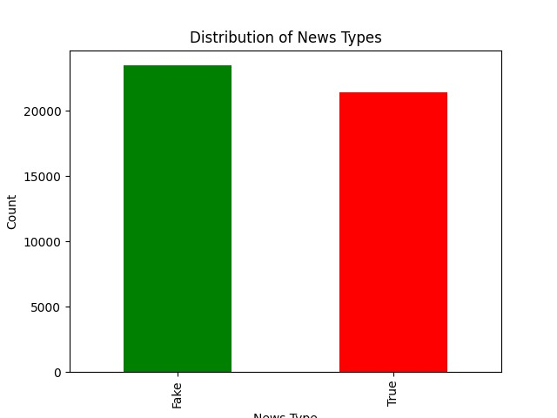

* The sample output shows the result of the algorithm using the NLTK process.
* It shows the probability of Fake news and True news of the given set.

**FEATURE EXTRACTION :**

**Bag of Words (BoW):**

* Represent text as a collection of words, disregarding grammar and word order.

**TF-IDF (Term Frequency-Inverse Document Frequency):**

* Weighs the importance of words based on their frequency in a document relative to their frequency across all documents.

**Word Embeddings** (e.g., Word2Vec, GloVe):

* Represents words as dense vectors capturing semantic relationships.

**N-grams:**

* Considers sequences of adjacent words to capture contextual information.

**Sentiment Analysis Scores:**

* Incorporates sentiment polarity as a feature.

**Named Entity Recognition (NER):**

* Identifies and categorizes entities like people, organizations, and locations.

**CLASSIFICATION ALGORITHM :**

**Naive Bayes:**

* Efficient for text classification tasks, especially with limited data.

**Logistic Regression:**

* Simple yet effective, suitable for binary classification tasks.

**Support Vector Machines (SVM):**

* Powerful for high-dimensional data, effective in text classification.

**Random Forest:**

* Ensemble method providing robustness and accuracy.

**Gradient Boosting** (e.g., XGBoost):

* Builds multiple weak models to create a strong classifier.

**Neural Networks** (e.g., LSTM, GRU):

* Deep learning models for complex patterns, effective in NLP tasks
* **DEEP LEARNING : (CNNs & RNNs)**

Deep Learning is a subset of machine learning that involves the use of artificial neural networks with multiple layers, allowing it to analyze and recognize complex patterns in data. In the context of fake news detection

**Deep Neural Networks**: These are algorithms that consist of multiple layers of interconnected nodes (neurons), enabling them to learn hierarchical representations of data. Each layer processes the input data and passes it to the next layer for further abstraction and analysis.

**Detection of Manipulation or Fabrication**: Deep learning models can be trained on large datasets of genuine and manipulated media content. By learning from these datasets, they can identify subtle visual or temporal cues that indicate alterations, enhancements, or fabrications in images and videos

**MODEL TRAINING :**

**Splitting the Dataset:**

* Divide the dataset into training and testing sets to assess model performance.

**Vectorization:**

* Transform text features into numerical vectors using chosen techniques like TF-IDF.

**Choosing a Model:**

* Select an appropriate classification algorithm based on the nature of the problem and dataset.

**Hyperparameter Tuning:**

* Fine-tune model parameters for optimal performance using techniques like grid search.

**Training the Model:**

* Feed the training data into the chosen algorithm, allowing the model to learn patterns and relationships.

**ALGORITHM :**

import pandas as pd

from sklearn.feature_extraction.text import TfidfVectorizer

from sklearn.model_selection import train_test_split

from sklearn.ensemble import RandomForestClassifier

from sklearn.metrics import accuracy_score, classification_report

import nltk

from nltk.corpus import stopwords

from nltk.stem import WordNetLemmatizer

import matplotlib.pyplot as plt

# Load the true and false datasets

true_data = pd.read_excel("true.xlsx")

false_data = pd.read_excel("false.xlsx")

# Combine the datasets into one

true_data['label'] = 1

false_data['label'] = 0

data = pd.concat([true_data, false_data], ignore_index=True)

# Text Preprocessing

nltk.download('stopwords')

nltk.download('wordnet')

lemmatizer = WordNetLemmatizer()

stop_words = set(stopwords.words('english'))

def preprocess_text(text):

words = text.split()

words = [word for word in words if word not in stop_words]

words = [lemmatizer.lemmatize(word) for word in words]

return ' '.join(words)

data['text'] = data['text'].str.lower()

data['text'] = data['text'].apply(preprocess_text)

# Feature Extraction: TF-IDF vectorization

tfidf_vectorizer = TfidfVectorizer(max_features=5000) # You can adjust max_features as needed

X = tfidf_vectorizer.fit_transform(data['text'])

y = data['label']

# Split the data into training and testing sets

X_train, X_test, y_train, y_test = train_test_split(X, y, test_size=0.2, random_state=42)

# Model Training: Random Forest Classifier

rf_classifier = RandomForestClassifier(n_estimators=100, random_state=42)

rf_classifier.fit(X_train, y_train)

# Model Evaluation

y_pred = rf_classifier.predict(X_test)

# Calculate accuracy and print classification report

accuracy = accuracy_score(y_test, y_pred)

report = classification_report(y_test, y_pred)

print("Accuracy:", accuracy)

print("Classification Report:\n", report)

# Create a simple accuracy plot

plt.bar(['Accuracy'], [accuracy], color='blue')

plt.ylim(0, 1) # Set the y-axis limit to show accuracy between 0 and 1

plt.ylabel('Accuracy')

plt.title('Fake News Detection Accuracy')

plt.show()

**OUTPUT :**

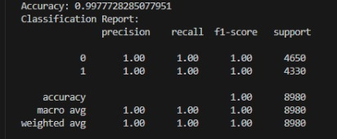

**KEYS IN (NLP) :**

* Data Quality Matters
* Evaluation Metrics
* Fine -Tunning
* Continuous Monitoring
* Interpretability

**GRAPHICAL REPRESENTATION :**

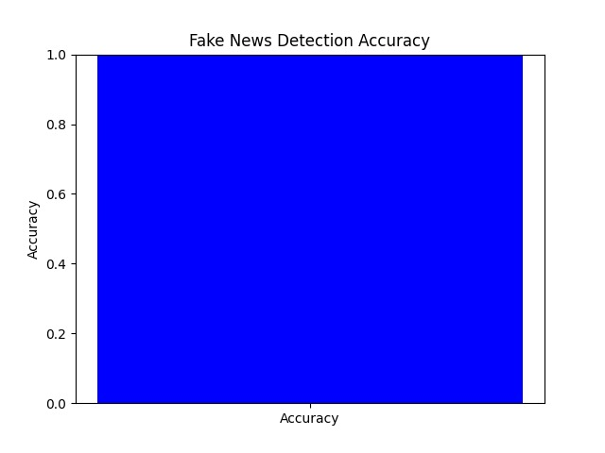

**ADVANTAGES :**

* Swiftly detects fake news as it emerges.
* Efficiently processes large datasets for widespread monitoring.
* Comprehends nuanced language patterns and cues.
* Verifies information against reliable sources to ensure accuracy.
* Can be trained to evolve with changing language and tactics.
* Automates the detection process, reducing reliance on human fact-checkers.
* Contributes to the credibility of news sources, fostering public trust.
* Applicable across languages and cultures for a global impact.

**DISADVANTAGES :**

* + - Risk of misclassifying legitimate information as fake news.
    - Models may inherit biases from training data, impacting accuracy in diverse contexts.
    - Adversarial actors may develop strategies to deceive NLP models.
    - Analyzing large textual data raises privacy issues.
    - Struggles with cultural nuances may lead to misinterpretation.

**CONCLUSION :**

In conclusion, while fake news detection using NLP presents significant advantages in timely identification, scalability, and language understanding, it is not without challenges. Potential disadvantages, such as the risk of false positives, biases, and the constant need for adaptation, underscore the complexity of the task. Striking a balance between automation and human judgment is crucial to avoid over-reliance and ensure nuanced comprehension. Privacy concerns, resource intensity, and cultural sensitivity further highlight the need for careful implementation and ongoing refinement. Despite these challenges, the continued development and responsible use of NLP technologies remain pivotal in the ongoing battle against misinformation, contributing to a more informed and resilient information landscape.